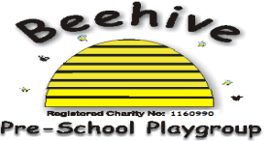

Low Moor Centre, Bray Road, Fulford, YO10 4JG – Telephone 01904 849100

Sun protection

**Purpose**

At Beehive, we wish for children to be able to enjoy the sun safely, and these are the procedures to follow to be able to do so. We have designed our outdoor play area so that there is a substantial covered area and also shade provided from trees, and these are the areas that children will be encouraged to play in on warm, summery days.

**Sun-cream**

When starting at Beehive, parents provide consent for staff to apply a suncream brought from the child’s home. If a parent does not provide consent, they will be expected to sign a disclaimer explaining that they take responsibility for any injury caused to their child from the sun. When arriving at Beehive in the summer time, please let staff know if sun-cream has already been applied that morning. Please ensure all sun-creams are in a named bottle and are within their expiry date.

**Clothing**

Please send your child to pre-school wearing a comfortable wide brimmed hat or legionnaire style cap and ensure that tops cover shoulders (avoid strappy tops).

This policy was adopted at a meeting of Beehive Pre-school playgroup held on

………………………………………….

Signed on behalf of the pre-school…………………………………….

Review Date……………………………………….