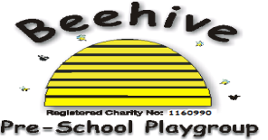
Low Moor Centre, Bray Road, Fulford, YO10 4JG – Telephone 01904 849100
Social Media
Purpose:
The purpose of this policy is to ensure that all staff members and families are aware of how to interact with Beehive on social media.

Procedure:
Employees must not make reference to Beehive or its services, or represent themselves on behalf of Beehive on social media without formal permission from Beehive to do so. It is not appropriate for members of staff to be “friends” with parents of children whom attend Beehive on any social media sites. Once a child leaves Beehive, this restriction is lifted.

Although Beehive has a Facebook page, this is intended as a communication tool for promoting fundraising activities and raising ad hoc queries from parents. There is also a closed group for current parents and families where, with permission, photos of children and activities may be uploaded. Membership of this group is monitored by members of staff and only those members with children currently on role are permitted to join. Parents provide written permission for their child’s photos to be added to the Facebook group and this written permission is held securely.

Photos uploaded by Beehive are not to be shared elsewhere on social media by parents.

This policy was adopted at a meeting of Beehive Pre-school playgroup held on ………..…
Signed on behalf of the pre-school………………………………………………

