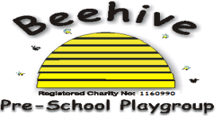
Low Moor Centre, Bray Road, Fulford, YO10 4JG – Telephone 01904 849100

Smoking

Purpose of Policy
The health of the staff and children at Beehive is of utmost importance and this is how we can avoid smoke-inhalation on the premises.

Procedure to follow
Beehive operates a strict no-smoking policy throughout the premises, which includes all interior and exterior locations. Beehive premises extend all the way down the walkway up to the car park.

All staff and parents/family are expected to follow this expectation and avoid use of any type of cigarette or vaping substance. This includes e-cigarettes. No smoking residue/litter is to be left anywhere on the Beehive premises.

For any staff member who chooses to smoke, they need to ensure this is out of view of Beehive, including the outside area, so that children do not observe smoking. In addition, a coat must be worn, so that Beehive clothing is not contaminated with smoke, which may pass onto children within close contact, such as cuddling.

If parents would like to smoke, please do this before turning the corner onto Bray Road so that any children do not observe this happening.

This policy was adopted at a meeting of Beehive Pre-school playgroup held on ………..…
Signed on behalf of the pre-school………………………………………………

