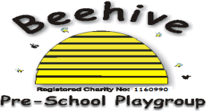
Low Moor Centre, Bray Road, Fulford, YO10 4JG – Telephone 01904 849100

Pets

Purpose of Policy
The aim of this policy is to ensure that all children are kept safe and that families are aware of where pets are allowed.

Procedure to follow

Pets can be a really important family member and children are often excited to share stories of their pets.
Pets such as cats and dogs are not allowed on the Beehive premises to ensure that children with allergies/fears of animals are kept safe.

If you have a different pet that you would like to bring in to show the children at Beehive, please speak to the supervisor and we will see if this is possible.

This policy was adopted at a meeting of Beehive Pre-school playgroup held on ………..…
Signed on behalf of the pre-school………………………………………………

