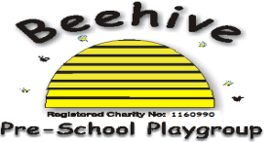

Low Moor Centre, Bray Road, Fulford, YO10 4JG – Telephone 01904 849100

Hand Washing

# Purpose of Policy

The purpose of this policy is to ensure that children are encouraged to wash their hands regularly, leading to good hygiene throughout Beehive.

**Procedure to follow**

Staff work hard to ensure children understand the importance of good hygiene. Staff work hard to lead by example by regularly washing their hands.

Children are helped to wash their hands at the following times:

* Before eating at snack and lunch time
* After going to the toilet
* After messy play, using paint or playdough
* After playing outside in the sand pit

Signs and posters are displayed throughout Beehive to encourage children in the correct way to wash hands.

This policy was adopted at a meeting of Beehive Pre-school playgroup held on ………..…

Signed on behalf of the pre-school………………………………………………