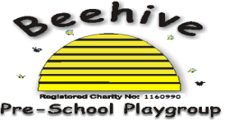

Low Moor Centre, Bray Road, Fulford, YO10 4JG – Telephone 01904 849100

Covid-19 staff policy

# Purpose of Policy

The purpose of this policy is to ensure that when a staff member tests positive for Covid that a clear procedure is followed.

**Procedure to follow**

When a staff member tests positive for Covid but feels well in themselves, they may attend Beehive but are advised to wear a mask as protection for others. If they choose not to attend work despite feeling well, they will not be paid during this absence.

If a staff member feels too ill to attend Beehive whilst testing positive for Covid, they should not attend, similar to if they had flu or another infectious disease. Staff members will receive sick pay in accordance with their contract. If they have used up all this sick pay for the period, they will not be paid for their absence.

There is currently no legal length of time for a person to be absent from work with Covid.

Common symptons of Covid are as follows: [People with symptoms of a respiratory infection including COVID-19 - GOV.UK (www.gov.uk)](https://www.gov.uk/guidance/people-with-symptoms-of-a-respiratory-infection-including-covid-19)

This policy was adopted at a meeting of Beehive Pre-school playgroup held on ………..…

Signed on behalf of the pre-school………………………………………………