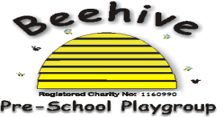

Low Moor Centre, Bray Road, Fulford, YO10 4JG – Telephone 01904 849100

Allergies

# Purpose of Policy

We want to ensure the safety of all children and that those with allergies have their needs met and that all are aware of any allergy requirements.

**Procedure to follow**

*Admissions*: When a child joins Beehive, it is vital that parents inform staff of any allergies and provide a care plan from the child’s doctor which informs staff of what the process is to follow for any allergic reaction. If medical items such as an inhaler or Epi-pen are required, it is imperative that these are promptly provided to Beehive and that they are in-date. These items will be stored in a locked box in the kitchen, out of reach of children but easy for adults to access.

*Staff knowledge*: The child’s care plan is displayed and promoted to all members of staff so that all are aware of the medical needs and what allergens to look out for. If any updates occur, it is important that parents communicate these promptly to staff in writing and provide doctor notes as needed.

*Provision of foods*: Allergen-friendly snack options are provided dairy and at our half-termly fundraises and family gatherings. We also ensure that baking completed by the children is free from allergens.

*Allergic reactions*: In case of an allergic reaction, staff will refer to the child’s care plan and follow all instructions. Medical advice will be sought as necessary.

This policy was adopted at a meeting of Beehive Pre-school playgroup held on ………..…

Signed on behalf of the pre-school………………………………………………